1. Log into dpcloud.
2. Open Excel Online
3. Create a new workbook.
4. In you new workbook, click on Survey->New Survey.

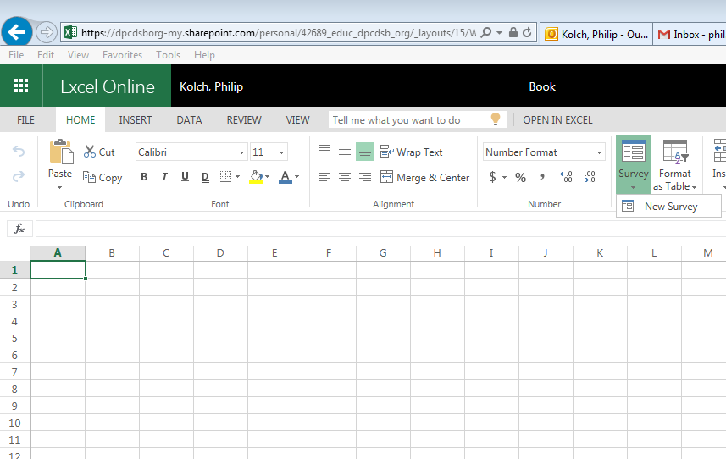

1. On the next screen enter in all your questions.

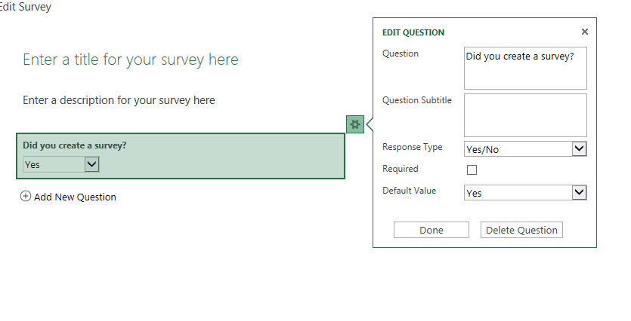

1. Then click on the Share Survey button once complete.

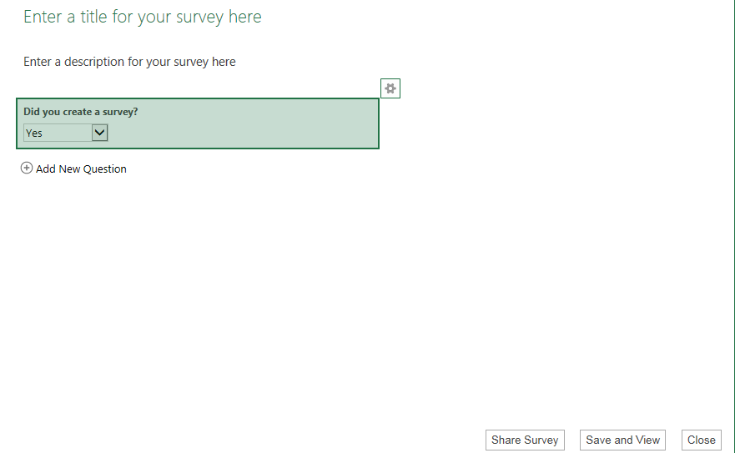

1. Copy and paste link from survey into e-mail.

